

Font size: 30px Font family:Roboto Conde... Font weight: bold



Color: #32b5e5 Font size:48px Font family: Fredoka One



Color:#ff4a04



Color: #32b5e5 Font size:28px Font family: Fredoka One

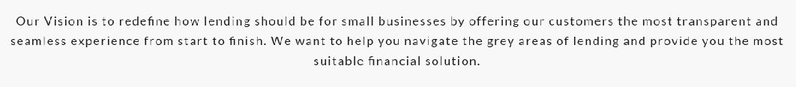

Color: #1c1c1c Font size:18px Font family: Lato



Color: #ff4a04 Font size:28px Font family: Fredoka One



Font size:48px Font family: Fredoka One



Font size:28px Font family: Fredoka One



Font size:18px Font family: Lato